https://yewtu.be/watch?v=PYUyPFDs9qA
Lowercase and copying data

Use formula on first row of column
Then do double click right side
Then use paste special

To remove currency sign
Select column, go to home, make it a number

No need for index column

Numbers can be made into date time etc using home>numbers
Also have option for text

https://yewtu.be/watch?v=_jmiEGZ6PIY

https://www.simonsezit.com/article/excel-crash-course-data-cleaning-in-excel-in-1-hour/

Double line double click to fit to biggest size of column

Removing blanks
Select all columns
Home> find and select> Go to special> Blanks
It will highlight and select blanks
Then Home> cells> delete> delete sheet rows

Select row
Clear> Clear formatting

PROPER(TRIM(C2))
To do both at once

Split using Text to column in data

Cross and shift
For shifting

LIKERT SCALE
LIKERT SCALE TABLEAU TUTORIAL

LOLLIPOP CHART
https://youtu.be/BpyG3u4mp1g?feature=shared

Make table look good
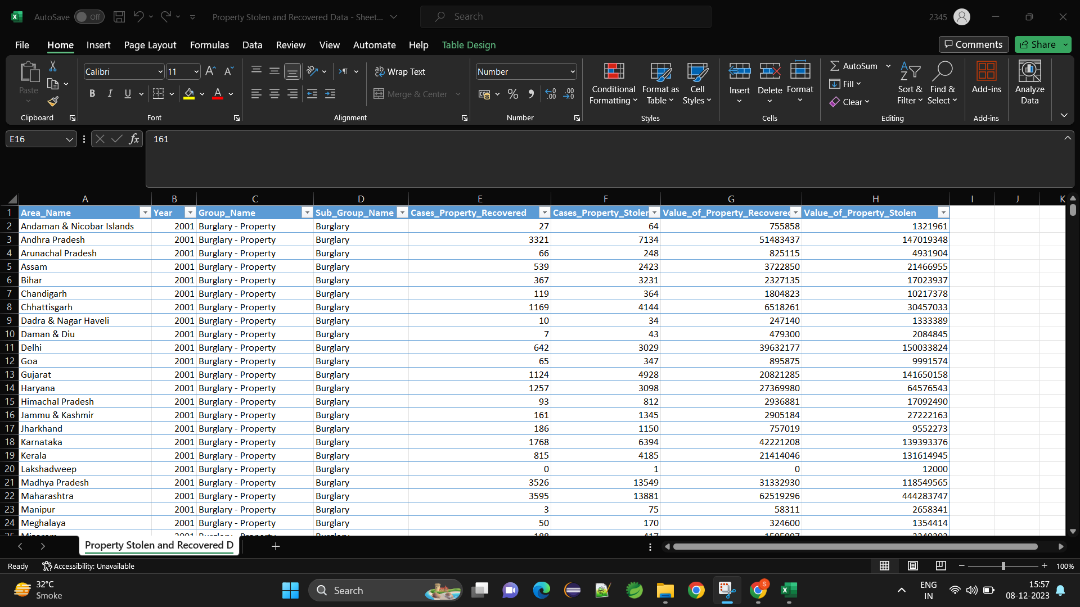
home> style> format as table
Can use color but also filter option

WORD CLOUD
How to create a word cloud in Tableau

HEAT MAP
How to Create a Heat Map in Tableau
Learn to create Tableau Heat Map

CHOROPLETH MAP
How to Create a Choropleth Map in Tableau
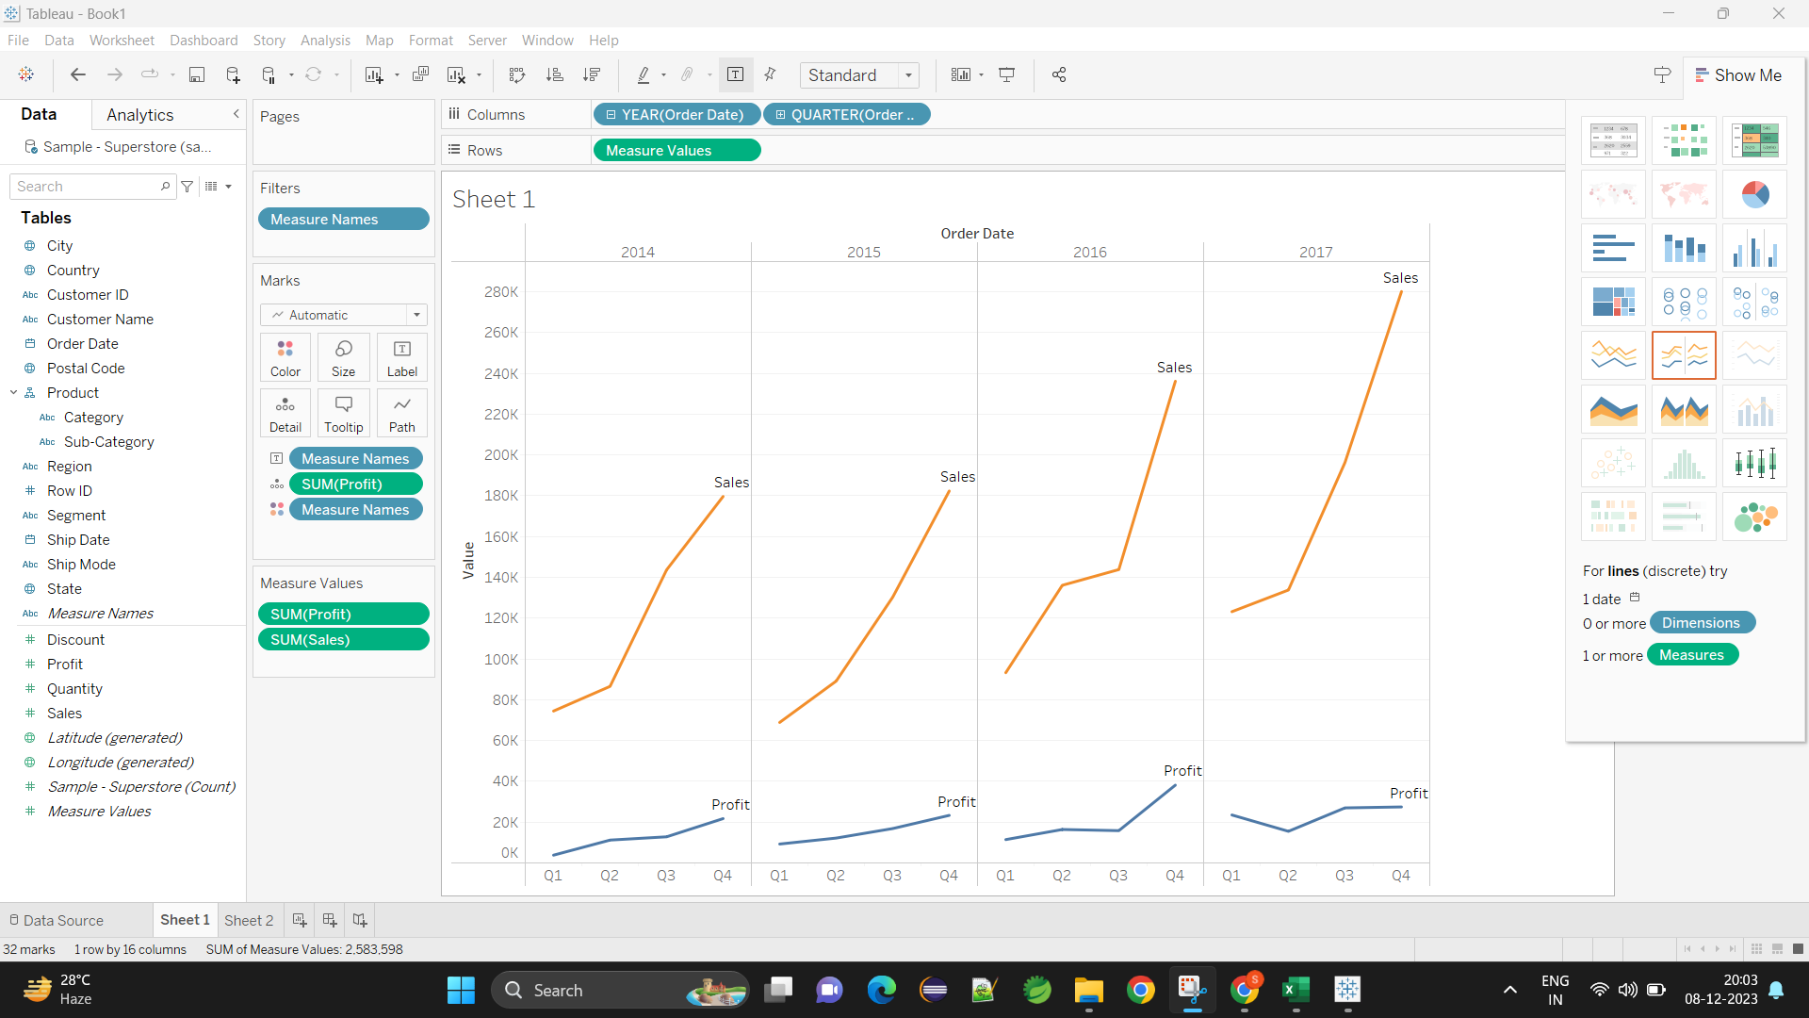

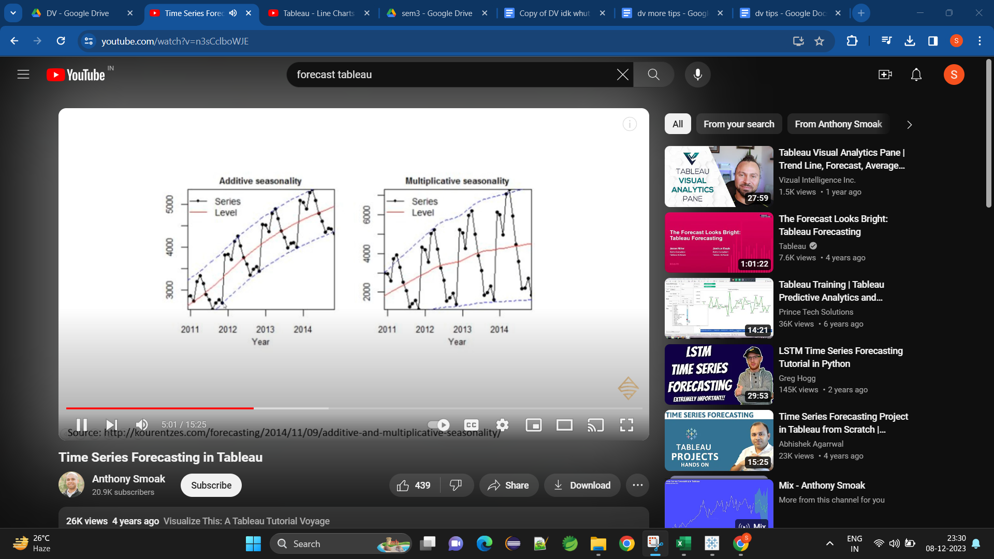

Please add the Forecast Indicator from Color to Tooltip.
Right Click and remove the Prediction Intervals if not needed
Time Series Forecasting in Tableau

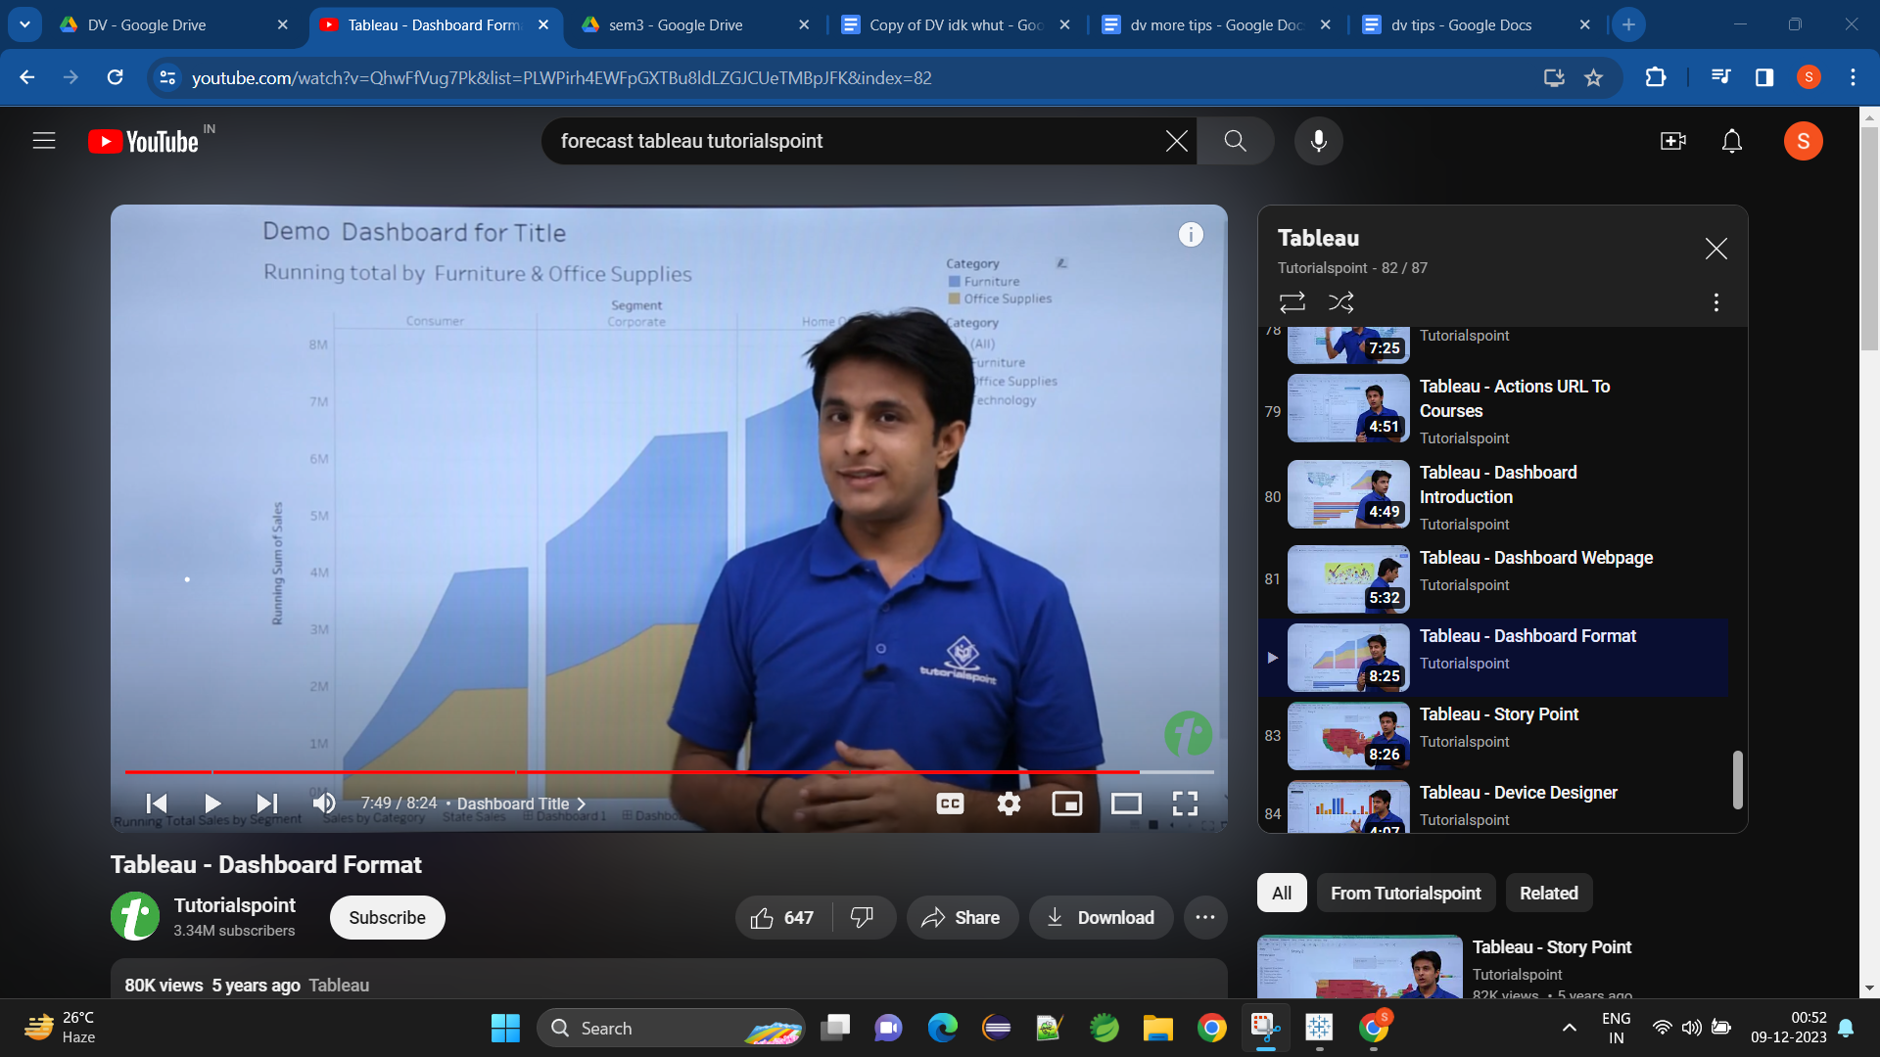

Lolipop Chart:https://www.youtube.com/embed/BpyG3u4mp1g?t=76

Bar in Bar Chart https://www.youtube.com/embed/JLsqtXefvTk?t=169

Word Cloud:https://www.youtube.com/embed/gWnv5PznQlk?t=74

Likert Visualization:
https://www.youtube.com/embed/6uX7ulGW5CE

Heat/Chloropleth Map:
https://www.youtube.com/embed/VVH0l1qytAg?t=350
https://www.youtube.com/embed/_0V22pbfO38?t=454

time series:
https://www.youtube.com/embed/n3sCclboWJE?t=812

Donut Chart:
https://www.youtube.com/embed/ZfpUzp8mBSw?t=188
https://www.youtube.com/embed/IXVI08LA1BY?t=137

Color cells based on value ONLY NEED TO WATCH THE FIRST 1:22
https://yewtu.be/watch?v=TETJXc-c_Ps

